FOR IMMEDIATE RELEASE

Press Contact: Corey Lonberger and Ken Wellar

Managing Partners
215-454-2852

RITTENHOUSE REALTY ADVISORS SELLS 55 LOFT APARTMENTS AND 1 COMMERCIAL UNIT FOR $7,900,000
PHILADELPHIA, PA--(2/12/19) – Rittenhouse Realty Advisors is pleased to announce the sale of the Keystone Lofts in the Tacony/Lower Mayfair neighborhood in Northeast Philadelphia. The property, which is located just a 20-minute drive from Center City, Philadelphia, sold to an international buyer at over $140,000 per unit, a record price for Northeast Philadelphia.
The property was originally built as warehouse in 1923 and was converted into apartments in the late 1980s. It now contains 55 apartments and 1 commercial unit. There are two freight elevators primarily used for tenant move-ins/move-outs. Every floor plan is unique with features that include ceilings up to 30’ high, sweeping views and distinguished hardwood floors. Keystone Lofts is located on approximately 2.8 acres of land with over 100 parking spaces secured by an electronic security access gate.
Ken Wellar, Managing Partner of RRA, stated: “We are seeing more foreign capital purchase assets in the Philadelphia region, which is driving up pricing. We successfully closed this transaction at a record price per unit in the neighborhood on behalf of the sellers, Liss Property Group, who are one of the largest owners in the Northeast with over 1,500 units.”

For more information on current rates or to view our available listings visit www.RittenhouseRealty.com.
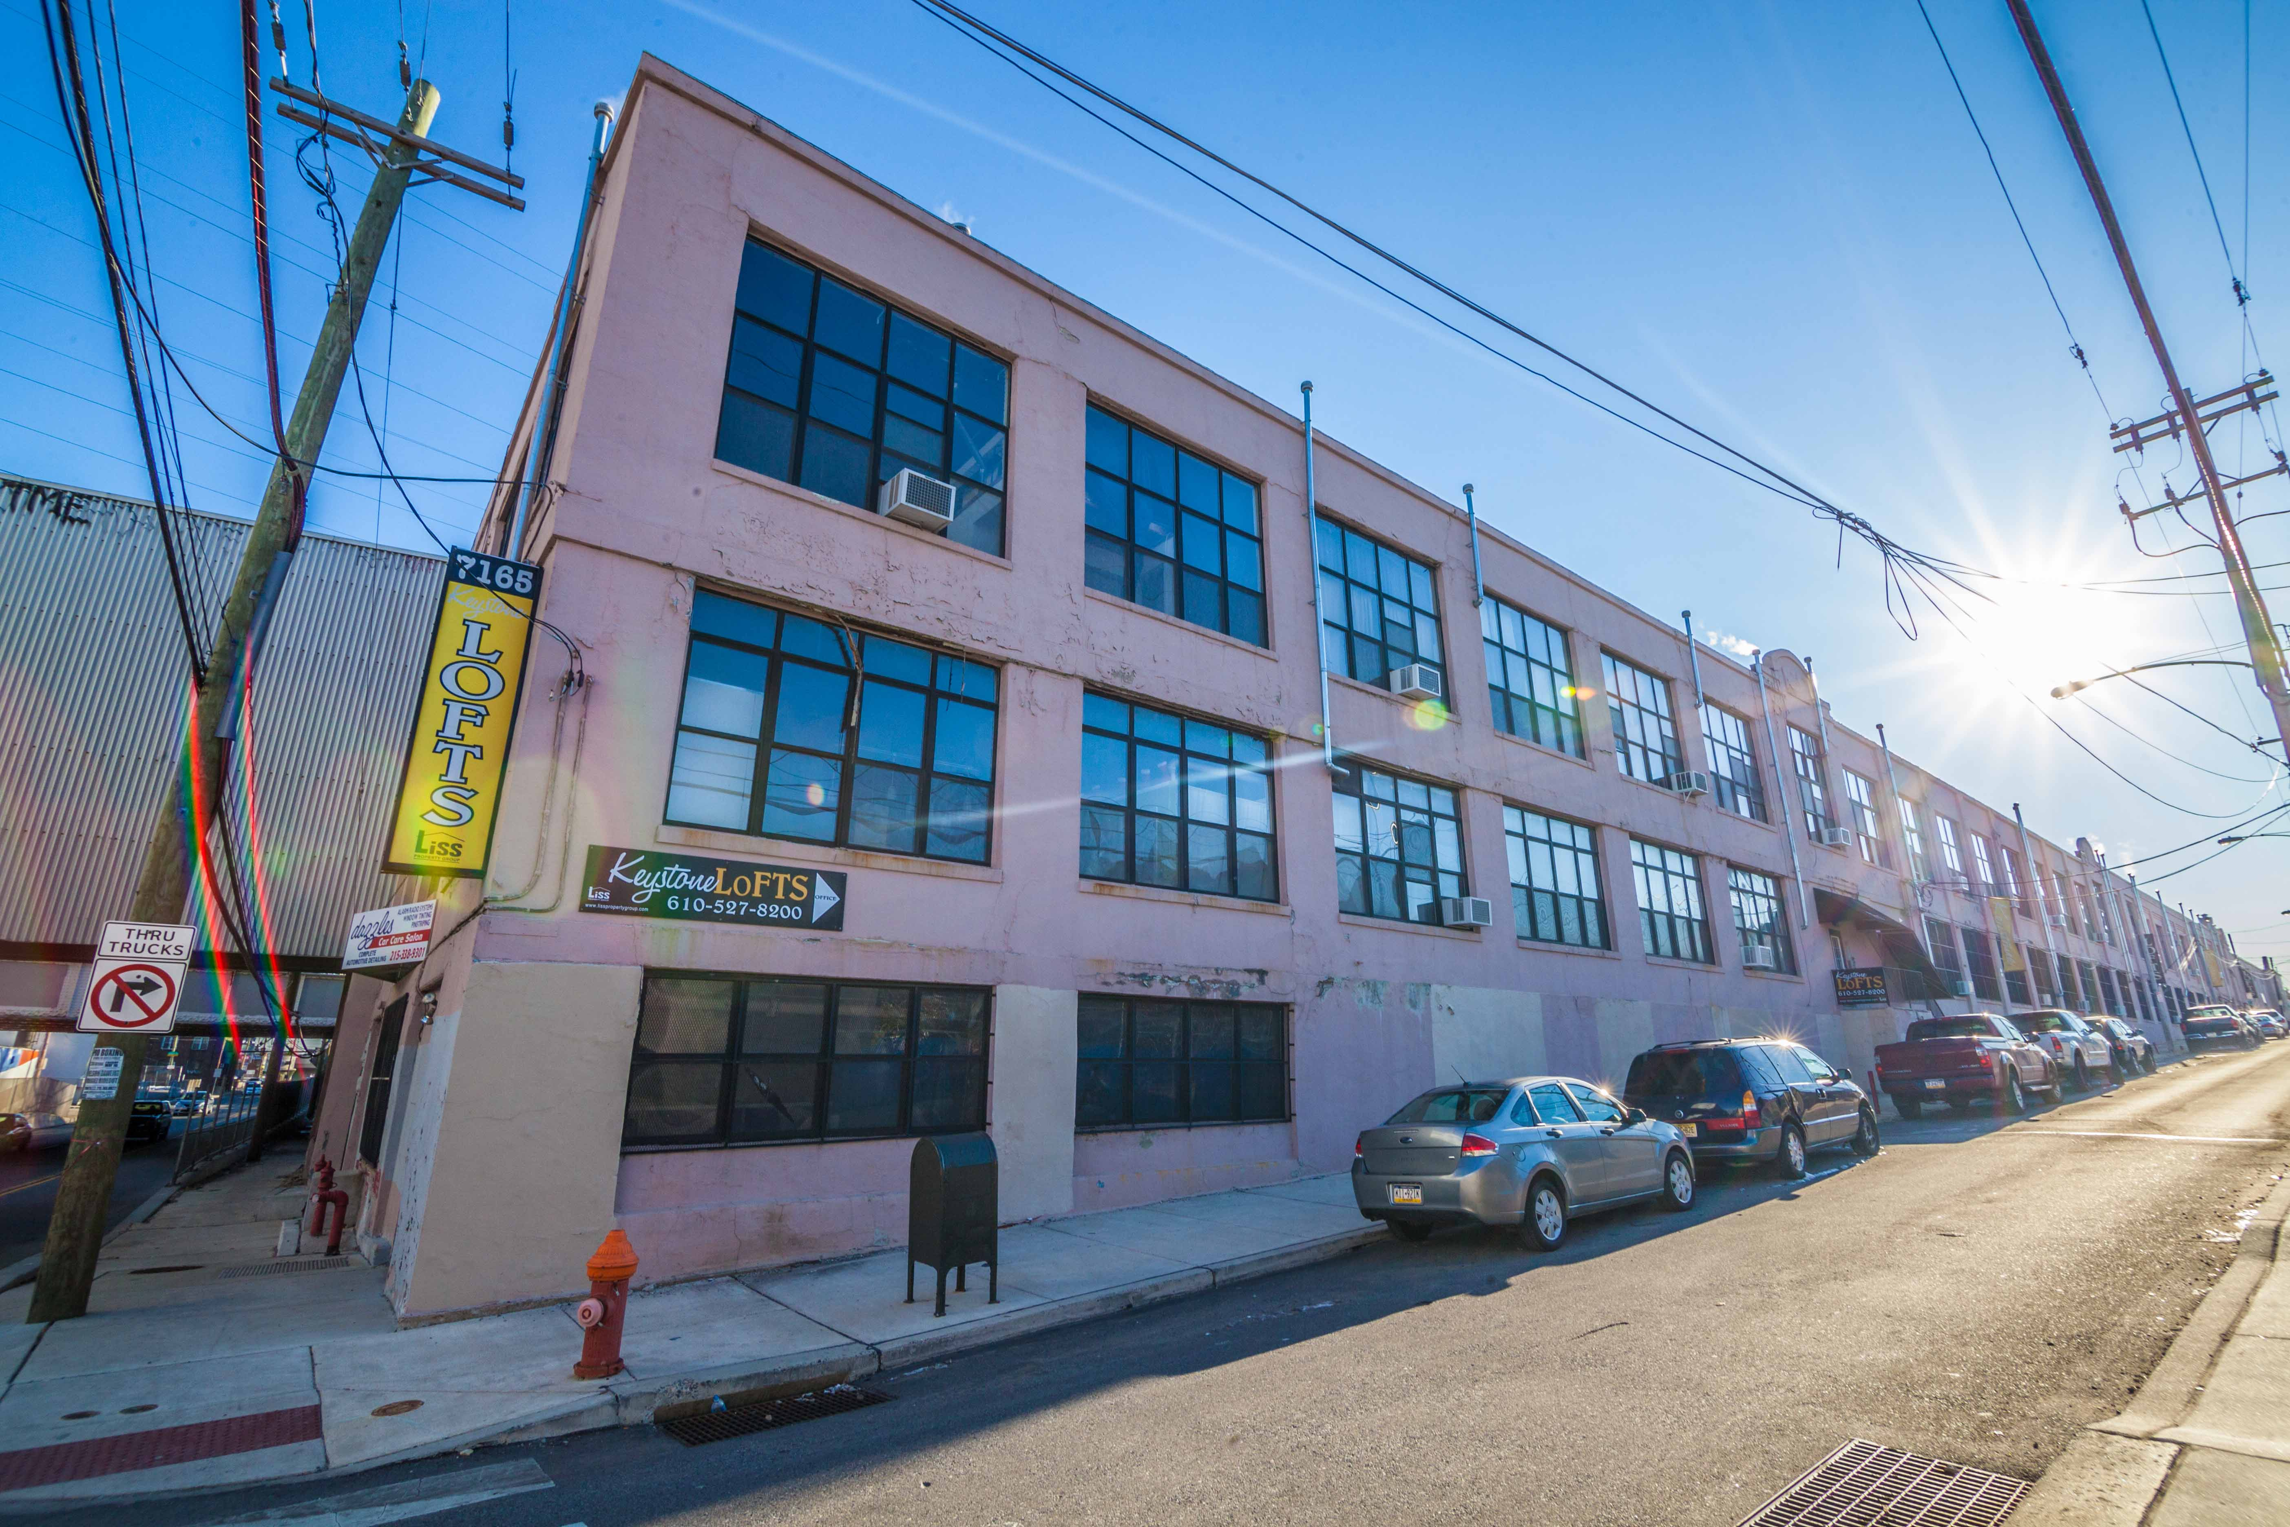

Based in Philadelphia, Pennsylvania, Rittenhouse Realty Advisors is a real estate advisory firm with an extensive focus in the brokerage of multi-family communities throughout the northeast region of the United States. Formed in February 2013 by a group of advisors with more than 30 years of commercial investment sales experience, our focus is on multi-family and mixed-use properties with significant residential components.
www.RittenhouseRealty.com

